EXPRESS.JS BASICS ASSIGNMENT
Routes, Parameters, Query Handling & Request Logging
Student: Sasanka Sekhar Kundu
Technology: Node.js + Express.js
Project: express-basics-assignment

1. Objective
The objective of this assignment is to create and test a simple Express.js server with basic GET routes, dynamic route parameters, multiple route parameters, query parameters, and request-response logging.

2. Project Structure
express-basics-assignment/
├── server.js
├── package.json
└── README.md

3. Requirements and Implementation
Task | Route / Feature | Expected Result | Status
Task 1 | GET /, /about, /contact | Home, About and Contact messages | Completed
Task 2 | GET /user/:name | Hello john | Completed
Task 3 | GET /product/:id/:category | Product ID: 101, Category: electronics | Completed
Task 4 | GET /search?name=john&role=developer | Name: john, Role: developer | Completed
Task 5 | Request logging middleware | Method and URL in terminal | Completed

4. Basic Routes
The following GET routes were implemented:
- GET / → Welcome to Home Page
- GET /about → This is About Page
- GET /contact → This is Contact Page

5. Route Parameter
The /user/:name route accepts a dynamic name. The tested URLs /user/john and /user/sasanka returned Hello john and Hello sasanka respectively. The value is read with req.params.name.

6. Multiple Route Parameters
The /product/:id/:category route accepts both an ID and a category. The tested request /product/101/electronics returned: Product ID: 101, Category: electronics.
req.params.id → 101
req.params.category → electronics

7. Query Parameters
The /search endpoint reads values from the query string using req.query.name and req.query.role. The tested request /search?name=john&role=developer returned Name: john, Role: developer.
req.query.name → john
req.query.role → developer

8. Request-Response Logging
Middleware logs the HTTP method and original URL for every request. The terminal evidence shows the server running at http://localhost:3000 and records the tested GET requests, including /about, /contact, /user/john, /user/sasanka, /product/101/electronics and the search query.
console.log(`${req.method} ${req.originalUrl}`);

9. Practical Execution Evidence
The following screenshots document the browser and Postman testing performed for the assignment.
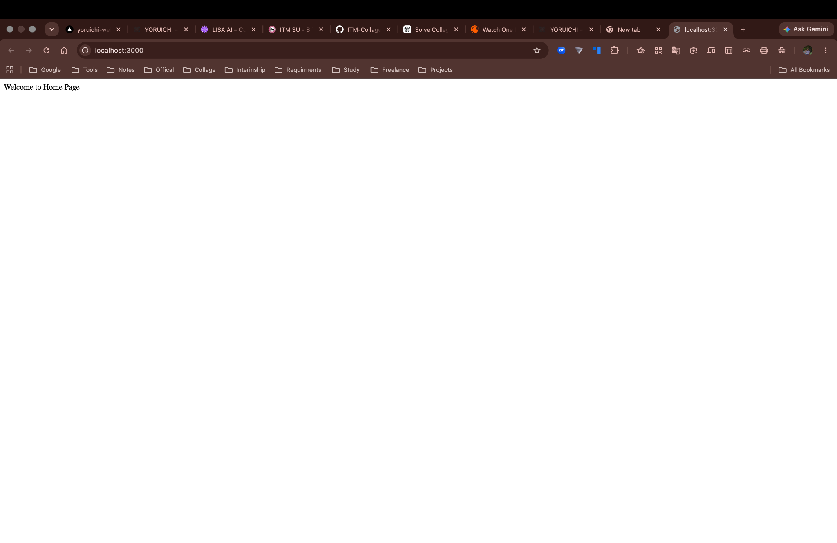
Figure 1 — Home route: GET / returned “Welcome to Home Page”.


Figure 2 — About route: GET /about returned “This is About Page”.


Figure 3 — Contact route: GET /contact returned “This is Contact Page”.


Figure 4 — Dynamic route: GET /user/john returned “Hello john”.


Figure 5 — Dynamic route: GET /user/sasanka returned “Hello sasanka”.

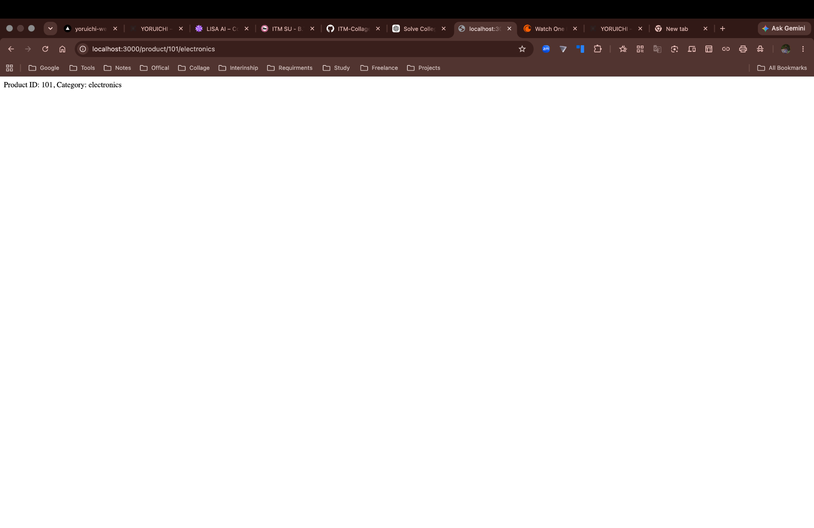
Figure 6 — Multiple parameters: GET /product/101/electronics returned the expected product ID and category.

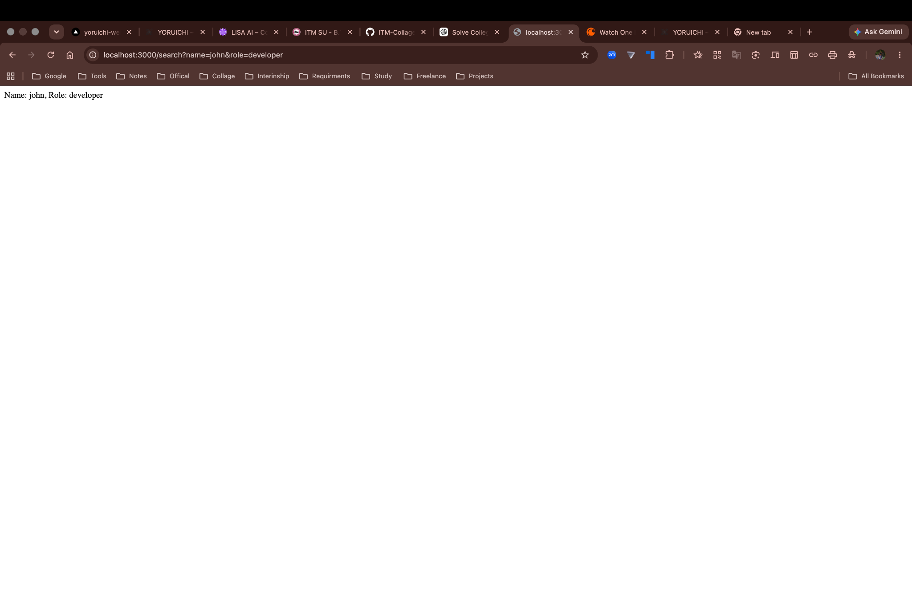
Figure 7 — Query parameters: GET /search?name=john&role=developer returned the expected name and role.

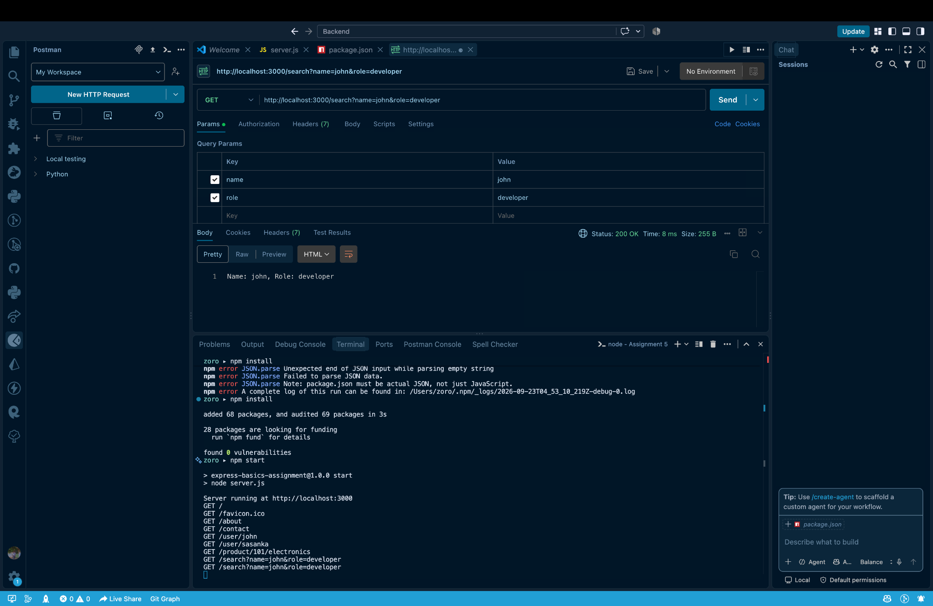
Figure 8 — Postman and terminal verification: the search request returned HTTP 200 and the terminal logged the request.

10. Result
All required Express.js routes were tested successfully. The browser evidence confirms the expected responses for the basic, dynamic, multiple-parameter and query-parameter routes. The Postman screenshot shows a successful HTTP 200 response, while the terminal output confirms request method and URL logging.

11. Conclusion
The assignment successfully demonstrates the fundamentals of Express.js routing and request handling. It covers app.get(), route parameters through req.params, query parameters through req.query, middleware, and request logging.

